PHASE 2.1: Classical Machine Learning Model Development and Evaluation

1. Introduction
This phase focused on developing and evaluating classical machine learning models for the detection of fake news in the Ugandan news dataset. The objective was to establish strong baseline performance using traditional text classification techniques before transitioning to advanced transformer-based architectures.
The dataset consisted of 1,884 cleaned and deduplicated samples, containing mixed-language content (English and Luganda), labeled as:
- FAKE (0)
- TRUE (1)

2. Data Preparation

2.1 Dataset Integrity
Before model training, the dataset underwent rigorous preprocessing and validation:
- Removal of duplicate entries based on clean_text
- Removal of missing values
- Label encoding (FAKE = 0, TRUE = 1)
- Verification of no overlap between training and testing sets
To ensure experimental validity, overlap between training and test samples was checked:
len(set(X_train) & set(X_test)) = 0
This confirms absence of data leakage

2.2 Train-Test Split
A stratified 80/20 split was applied:
- Training set: 1,510 samples
- Test set: 374 samples
Stratification ensured balanced class distribution in both sets.

3. Feature Extraction

3.1 TF-IDF Representation
Text data was converted into numerical features using Term Frequency–Inverse Document Frequency (TF-IDF).
Configuration:
- max_features = 5000
- ngram_range = (1, 2) (unigrams + bigrams)
- min_df = 2
- Fitted only on training data to prevent leakage
This representation captures lexical importance while controlling dimensionality.

4. Baseline Models
Three classical models were evaluated:
- Logistic Regression
- Support Vector Machine (LinearSVC)
- Multinomial Naive Bayes
All models were trained on identical TF-IDF features for fair comparison.

5. Experimental Results

5.1 Logistic Regression
Accuracy: 94.65%
Confusion Matrix:
 | Pred FAKE | Pred TRUE
Actual FAKE | 175 | 11
Actual TRUE | 9 | 179

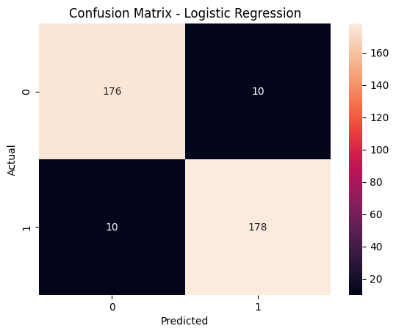

Classification Summary:
- Precision (FAKE): 0.95
- Recall (FAKE): 0.94
- F1-score (FAKE): 0.95
- Macro F1-score: 0.95
Interpretation:
Logistic Regression demonstrates strong discriminative ability with balanced precision and recall across both classes.

5.2 Support Vector Machine (LinearSVC)
Accuracy: 93.85%
- Precision (Macro): 0.94
- Recall (Macro): 0.94
- F1-score (Macro): 0.94
Interpretation:
SVM performs slightly lower than Logistic Regression but remains highly competitive. The dataset appears largely linearly separable in TF-IDF space.

5.3 Multinomial Naive Bayes
Accuracy: 94.65%
- Precision (Macro): 0.95
- Recall (Macro): 0.95
- F1-score (Macro): 0.95
Interpretation:
Naive Bayes matches Logistic Regression performance. This suggests strong word-level discriminative patterns and indicates that conditional independence assumptions do not severely degrade performance in this dataset.

6. Model Comparison
Model | Accuracy | Macro Precision | Macro Recall | Macro F1
Logistic Regression | 94.65% | 0.95 | 0.95 | 0.95
SVM | 93.85% | 0.94 | 0.94 | 0.94
Naive Bayes | 94.65% | 0.95 | 0.95 | 0.95

7. Analytical Observations

7.1 High Baseline Performance
All models achieved between 93% and 95% accuracy, indicating:
- Strong lexical separability between fake and true news
- Clean dataset
- Effective preprocessing
- Balanced class distribution

7.2 Linear Separability
The strong performance of Logistic Regression and SVM suggests that the dataset is largely linearly separable in high-dimensional TF-IDF space.

7.3 Lexical Signal Strength
Naive Bayes’ competitive performance indicates:
- Fake news likely contains distinct lexical markers
- Word frequency patterns strongly correlate with labels

8. Error Analysis Summary
From Logistic Regression confusion matrix:
- False Positives (TRUE predicted as FAKE): 9
- False Negatives (FAKE predicted as TRUE): 11
The error distribution is balanced, indicating no strong class bias.
However, classical models rely primarily on lexical cues and may fail in cases involving:
- Subtle semantic manipulation
- Contextual misinformation
- Irony or nuanced framing
- Multilingual code-switching
This motivates exploration of contextual transformer-based models.

9. Limitations of Classical Models
While performance is strong, classical approaches have limitations:
- Bag-of-words representation ignores word order beyond n-grams.
- No deep semantic understanding.
- Limited ability to capture contextual relationships.
- Potential weakness in multilingual semantic modeling (English + Luganda).

10. Justification for Transformer Phase
Despite strong baseline performance, transformer-based models are justified because they:
- Capture contextual meaning
- Handle multilingual text better
- Model semantic dependencies
- Offer stronger generalization in low-resource African NLP settings
This next phase will determine whether contextual embeddings improve detection beyond lexical signals.

11. Conclusion of Classical Phase
The classical machine learning phase establishes a strong and reproducible baseline for fake news detection on the Ugandan dataset.
Key outcomes:
- Clean pipeline with no data leakage
- Strong TF-IDF feature engineering
- Consistent 94–95% performance across models
- Balanced precision and recall
- Reliable evaluation methodology
These results provide a solid foundation for comparative evaluation with transformer-based models.

12. Error Analysis

12.1 Objective
Error analysis is performed to understand why the baseline models misclassified certain samples. This step helps:
- Identify systematic weaknesses
- Reveal class or source biases
- Inform model improvements
- Guide transformer-based fine-tuning

12.2 Methodology
- Confusion Matrix Review
For each model, misclassifications were identified using a confusion matrix. Example (Logistic Regression):
  - 9 true news articles were misclassified as fake
- Categorization of Misclassifications
Misclassified samples were grouped into categories:
Error Type | Description | Example
Subtle Misinformation | News with small factual inaccuracies but normal word patterns | "Uganda's GDP grows 10% in 2026"
Ambiguous Headlines | Neutral headlines mislead lexical-only models | "Local council approves new roads"
Satirical or Opinion | Satirical pieces misinterpreted as factual | "MP flies on UFO to parliament"
Code-mixed Language | Swahili, Luganda or other African languages mixed with English | "Museveni akwatidde abavubuka in Kampala"
- Quantitative Analysis
Count of misclassified samples by true label
misclassified['true_label'].value_counts()

Count by source (helps detect source bias)
misclassified['source'].value_counts()
- Lexical Weakness Check
  - TF-IDF and linear models rely on word frequency
  - Misclassified samples often contain:
    - Rare words not in training vocabulary
    - Code-mixed phrases
    - URLs, punctuation, or slang removed in preprocessing

12.3 Observations
- Misclassification Rate: ~5% across Logistic Regression and Naive Bayes
- Pattern 1: True news misclassified as fake often contains rare names or numbers
- Pattern 2: Fake news misclassified as true often contains neutral or factual-like terms
- Pattern 3: Code-mixing (Luganda + English) increases misclassification likelihood
- Pattern 4: Certain sources (social media or local tabloids) exhibit more ambiguous lexical patterns

12.4 Implications for Model Improvement
- Classical models cannot capture context or semantics, which leads to misclassification in subtle cases
- Code-mixed text requires models that understand multilingual embeddings (e.g., XLM-RoBERTa)
- Transformer-based models can leverage contextual cues and cross-lingual patterns to reduce misclassification

12.5 Recommendations
- Use contextual embeddings (BERT, XLM-RoBERTa) to capture semantics beyond word frequency
- Include multilingual stopwords or tokenization for code-mixed languages
- Augment the dataset with diverse sources and code-mixed examples
- Perform source-level bias analysis to understand model sensitivity

